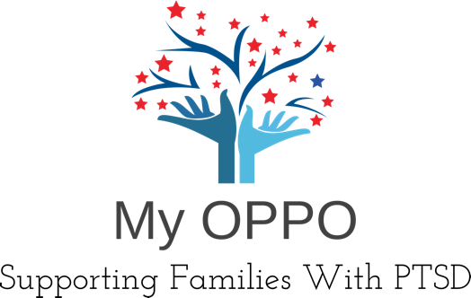

My Oppo - Supporting Families with PTSD respects and seeks to preserve the confidentiality of all our clients.

Confidentiality is based on the common law ‘Duty of Confidence’ and is shared between our clients and our helpline service, not the individual worker.

In exceptional circumstances, confidentiality may be broken and personal or identifying details may need to be passed on to third parties. Below is a list of situations confidentiality will be broken without the consent of the client;

- When the client has informed the helpline that they have serious intent or injury and have acted to take their own (or someone else’s) life at this time.
- When a client has informed our helpline service they have information about current or future terrorist activities.
- When a client has revealed that they are abusing an adult, child or vulnerable person(s).
- Should it be considered essential to a clients wellbeing, and the client requests it and provides information detailing circumstance, location and contact information this will be passed onto emergency services, in appropriate circumstances, where a client is unable or unwilling to do this for themselves.

All information will be stored by My Oppo – including electronic conversations. All information is stored securely.

You have the right to ask for a copy of the records we hold of you, although we may charge £10 to cover the costs involved.

Sharing your story – you may wish to share your story/experiences on our online platforms and/or in face-to-face meetings, this will never be shared to third parties without your explicit and informed consent, unless any of the situations as listed above are present.

We may, in some cases use our platform to signpost clients to the necessary help they require, these include:

Samaritans – Crisis line

Alcoholics Anonymous (AA)
Citizens advice – Debt relief and other general advice
NHS – Health concerns

Please read carefully and sign below:

My Oppo will not be held accountable should I or a member of family do physical harm to either myself or another person.

I am aware that My Oppo are not a counselling service and will signpost to relevant organisations if needed.

I will not share any other individual’s stories/information taken from My Oppo’s online platform or during face-to-face meetings without the individuals consent.

I ………………………………………………………………. understand my rights in using My Oppo’s service and give my consent to all above information written on page 1 of 2 by signing this page.

Client’s information

Full name ………………………………………………….. D.O.B ……/……/…….

E-mail ………………………………………………………… Phone number ……………………………………..

NOK (1)………………………………………………………. Phone number ……………………………………..

NOK (2)……………………………………….……………… Phone number ……………………………………..

Personal address ………………………………………………………………………………………………………………………………………………

………………………………………………………………………………………………………………………………………………

GP and address ………………………………………………………………………………………………………………………………………………

………………………………………………………………………………………………………………………………………………
